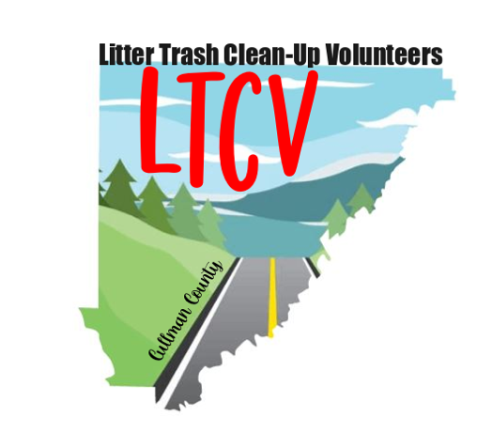

Name ______________________________________________

Address ____________________________________________

City _______________________________ State __________

Zip Code ___________ Telephone/Cell __________________

Email Address _______________________________________

Contact Notification choice Text Message _____ Email ______

Signature ___________________________

Please submit application by email to: priscotech@earthlink.net

or mail to: 5 County Road 182 - Crane Hill, AL. 35053

Note: Application for membership is limited to those over the age of 21

Once your application has been received, a liability release form will be emailed or sent out to be completed and returned.

***Litter Trash Clean Up Volunteers***

***Application For Membership***