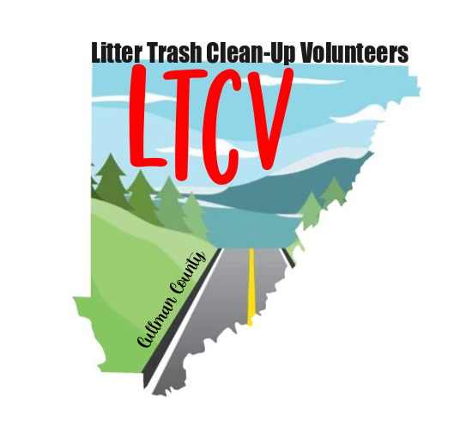

**RELEASE OF LIABILITY**

For and in consideration of the opportunity to participate in event(s) for

Litter Trash Clean-up Volunteers (LTCV), I (print name here)___________________________

hereby forever release from liability: 1) the volunteer group of Litter Trash

Clean-up Volunteers (LTCV) and any of its leaders, volunteers and/or agents, 2)

People Against A Littered State (PALS) and any of its officers, employees, and/or

agents, 3) the sponsors of the aforesaid, and any of their officers, employees,

and/or agents 4) the landowner(s) where the clean-up(s) and/or event(s) is

located, any of their officers, employees, and/or agents from any and all actions,

causes of actions, or claims of any kind whatsoever either for personal injury or

otherwise, arising or resulting from my participation in the aforesaid.

Dated:_______________



________________________________

Signature of Participant/ Legal Guardian