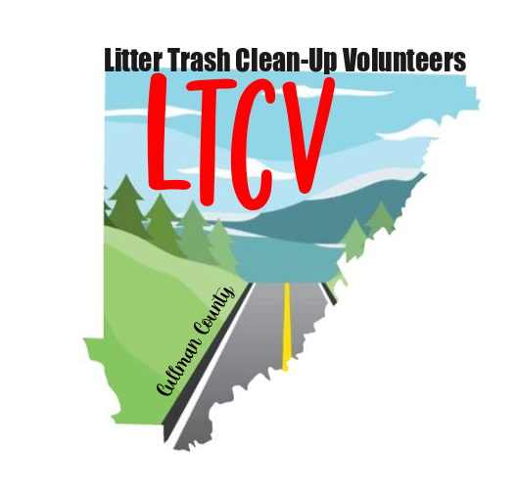

***Litter Trash Cleanup Volunteers (LTCV)***

***Roadside Pickup Procedures - 2023***

A. LTCV Cleanup's will consist of a two-hour event where all volunteers will work one side of the road, stop...then cross over to the other side. They will then head back towards their point of origin, picking up litter on this side of the road.

B. Volunteers are to remain directly in front of the Sheriff's patrol vehicle. The volunteers should pick up litter in close proximity to one another. This is a group effort therefore, each volunteer should remain conscious of the fact, that every participant, should receive an equal opportunity to collect litter.

C. All volunteers are to conduct the litter pickup process by remaining on the right-hand side of the road. No one should attempt to cross the road and pick up litter when facing oncoming traffic.

D. During the time allocated, breaks will be scheduled for rest and/or consumption of liquids.

E. All volunteers will be supplied with reflective vests, picker tongs and plastic litter bags. The vests and tongs will be turned in upon completion of the event.

F. The LTCV will set out "Litter Pickup" signs at both the point of origination and at the location where the group will cross the road, turn around, then head back towards their point of origination.

G. LTCV members are encouraged to bring gloves, bug spray and suntan lotion.

H. No children or anyone under twenty-one year's of age will be permitted to participate.

I. Do not pick up syringes or needles. Report any suspicious items to the "lead" member of the LTCV Team.

