
NEW LTCV Volunteer Signup Process
As of February 1, 2024

It has become apparent that for some reason the LTCV website was not meeting all the needs of our members. This year we simplified and modernized the signup page on our website. If you have any issues signing up for events, please contact LTCV at admin@ltcv.org. Here is the newly revised process in a detailed step-by-step manner.

- Open your internet browser and go to https://ltcv.org website to sign up for a pickup date. If on your smart phone, rotate to landscape mode (where phone is wider than it is tall) for better viewing.
- Click on the “Admin” menu in the upper right corner. If you are on a phone or small tablet, the menu can be found by clicking on the 3-line icon in upper right corner.
- The “Admin” menu is for members only, so there is a requirement to password-protect this part of the LTCV website. Once a member, the admin can provide the password. Enter the password to continue. It will not ask for the password every time. Please do not share this password to others that are not official LTCV members.
- On the “Member Sign-up” tab, click on the link “Click to Sign Up for an Event”.
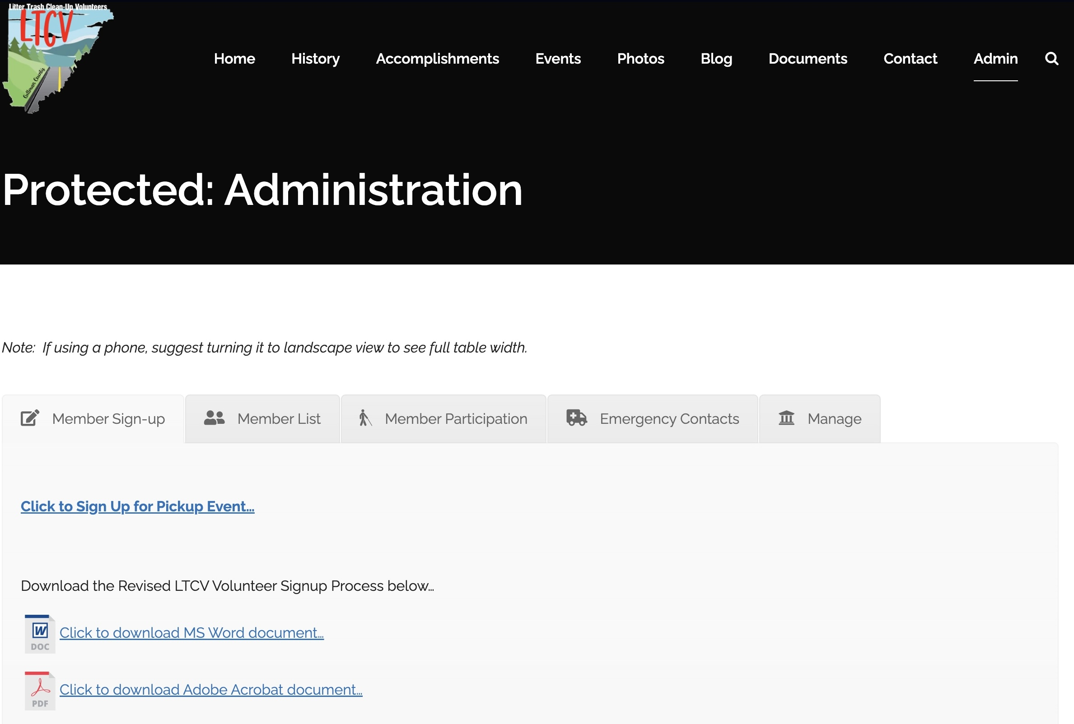
- The next window will show you all the pickup dates that are currently scheduled. Click on the circle by the event date you wish to commit to pick up. Then be sure to click on the Submit button at the bottom of the window.
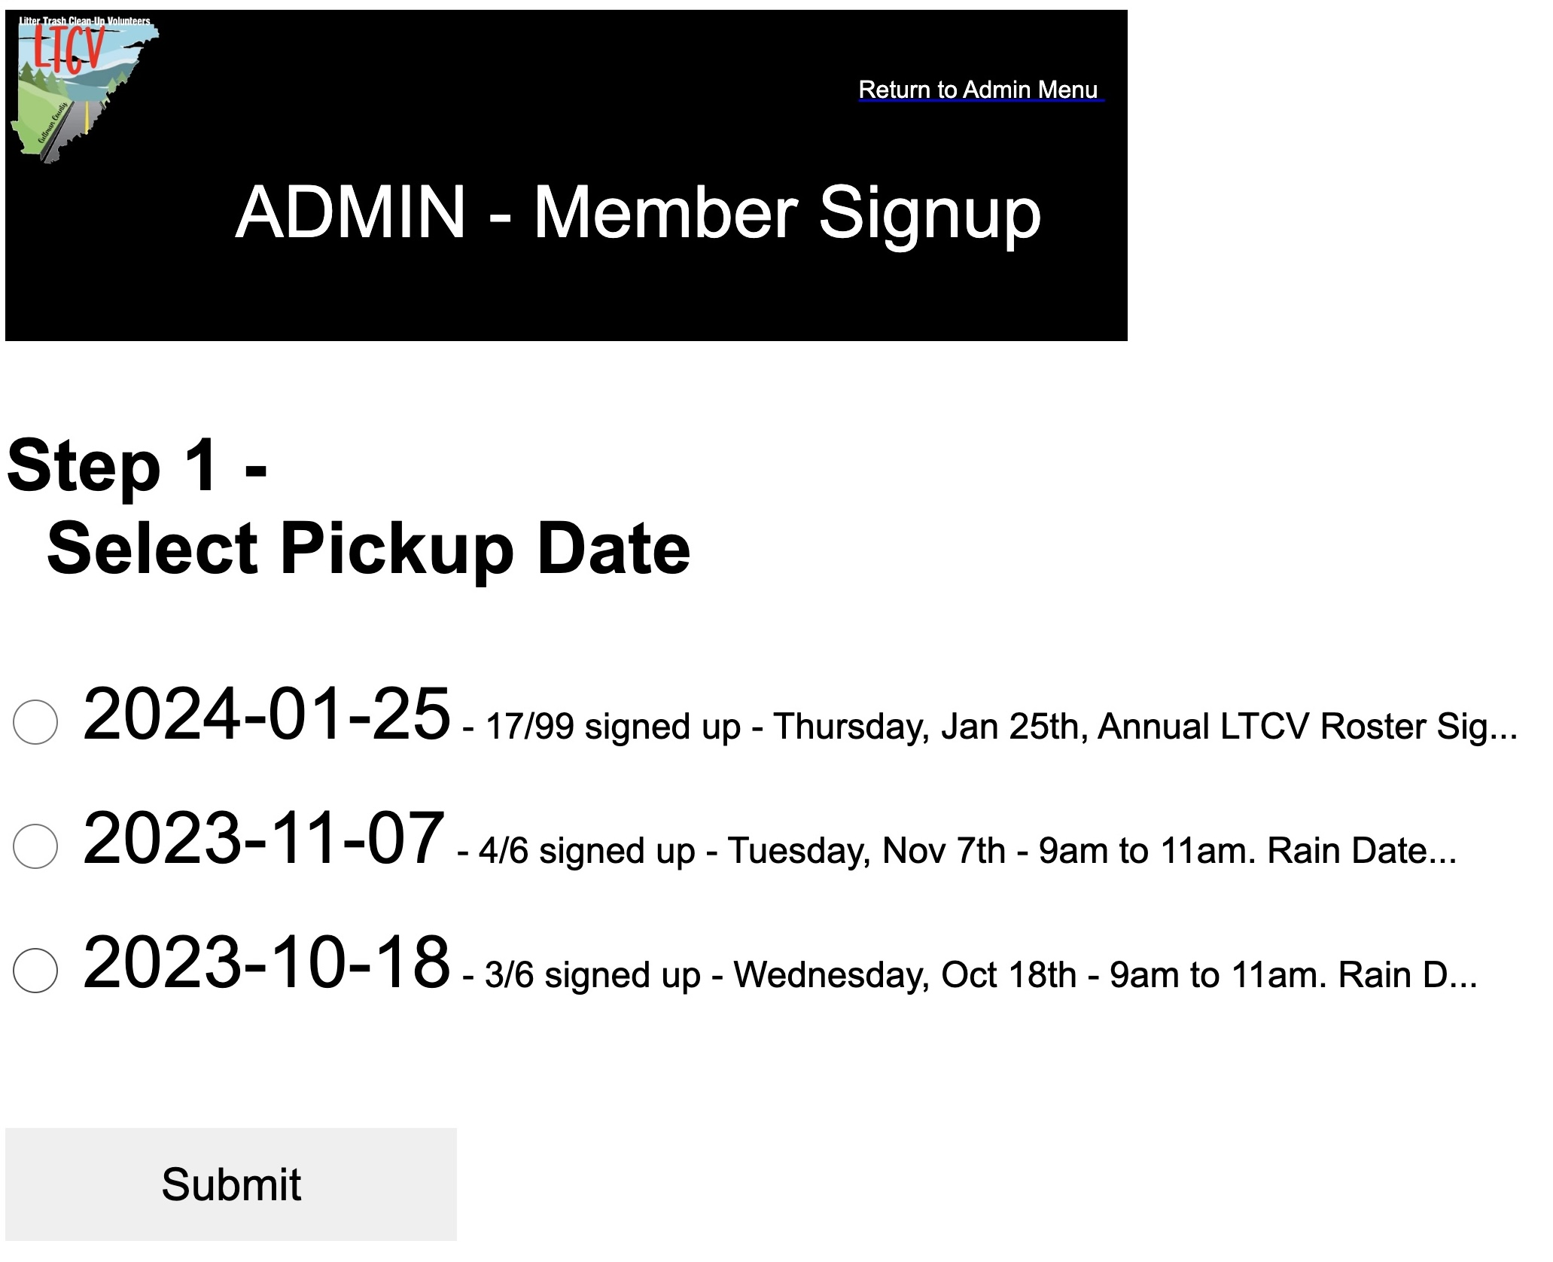
- The window updates with a list of LTCV members. Some have a checkbox that is checked by their name. Those members have signed up for the event. Those members that have a blank checkbox are not signed up. You can click on any of those boxes to sign up, or you can click on a checked box to remove the member from event. Once checking a box, the member should then click on the role box. The box should expand down with several choices of various roles. Select the role you wish to serve (ie. Pickup Volunteer) by clicking on the role. When finished, be sure to click on the Submit button at the bottom of the screen..
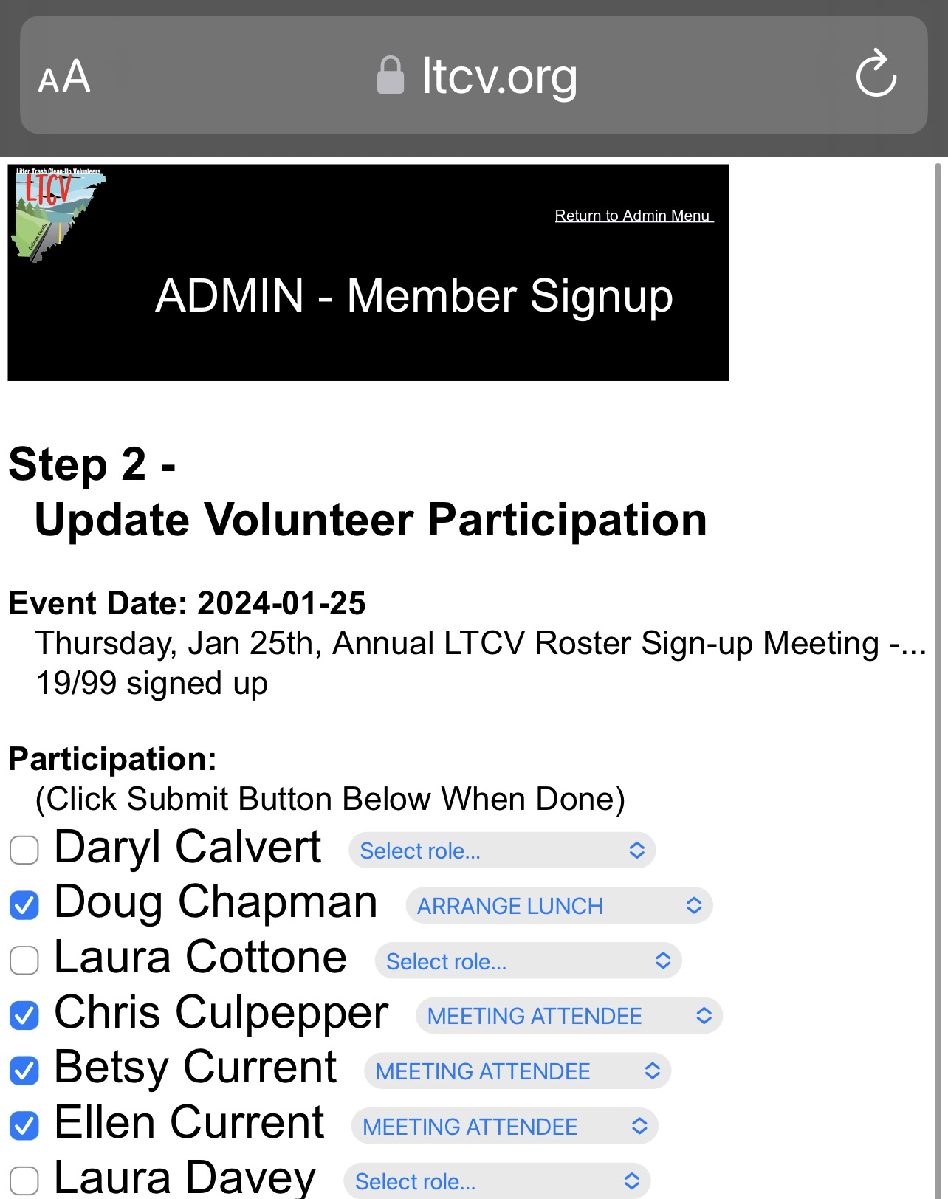
- The final screen will show the selected date of the event and all the members, and their roles, that are signed up for the event.
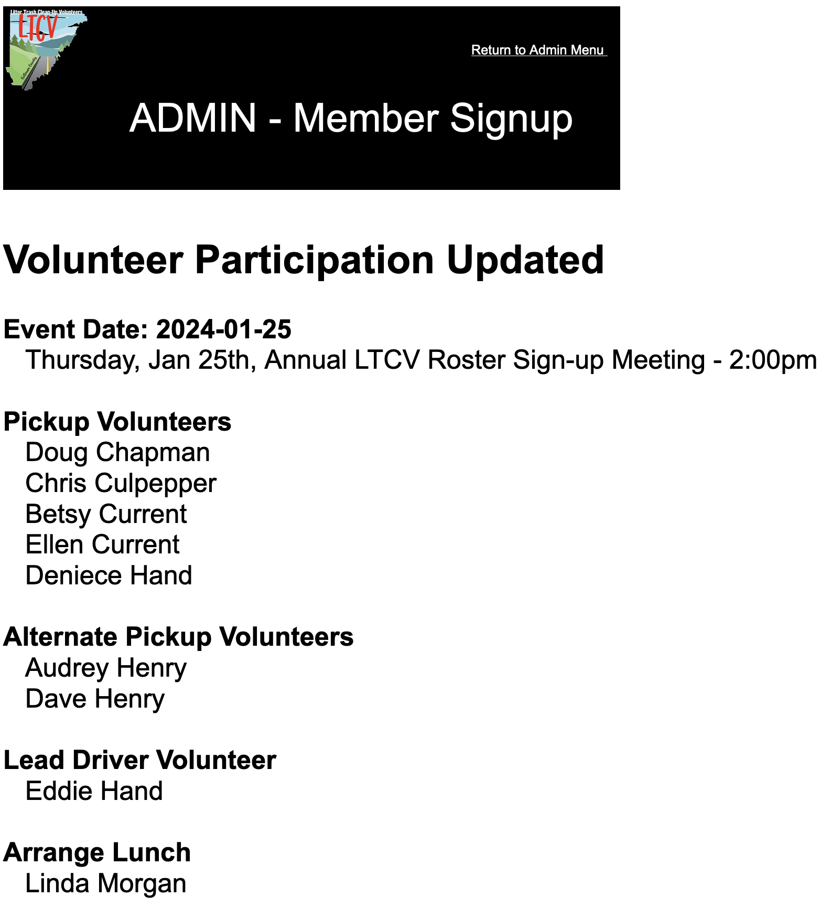

- To review another pickup date, click on the link at the bottom of the page. To return to the Admin menu, click on the link at the top-right corner of the page.

-Tom Miller

